

**Advanced Smart GPS & Electromagnetic Brake System**

**A PROJECT REPORT**

*Submitted by*

**M. SYED NIHAAL AHMED 17604231**

**T. RAKESH 16604252**

**S. SARATH 17604233**

**A. SYED DASTAGEER 17604248**

*In partial fulfillment for the award of the degree* *of*

**BACHELOR OF ENGINEERING**

*In*

**MECHANICAL ENGINEERING**

**SCHOOL OF ENGINEERING**

**VELS INSTITUTE OF SCIENCE TECHNOLOGY AND ADVANCED STUDIES**

**(VISTAS)**

**CHENNAI - 600 117**

**APRIL - MAY 2021**

**BONAFIDE CERTIFICATE**

Certified that this project “**ADVANCED SMART GPS AND ELECTROMAGNETIC BRAKING SYSTEM”** is the bonafide work of  **‘M. SYED NIHAAL AHMED (17604231); T. RAKESH (16604252); S.SARATH (17604233); A. SYED DASTAGEER (17604248)**’, who carried out the project work under my supervision. Certified further that to the best of my knowledge the work reported here in does not form part of any other project report or dissertation on the basic of which a degree or award was conferred on an early occasion on this or any other candidate.

**SIGNATURE SIGNATURE**

Dr.C.DHANASEKARAN Dr. S. SIVAGANESAN

**HEAD OF THE DEPARTMENT** **SUPERVISOR**

MECHANICAL ENGINEERING MECHANICAL ENGINEERING

VISTAS VISTAS

CHENNAI-600 117 CHENNAI-600 117

Submitted for the project work and viva-voce examination held on ………………. at

VELS UNIVERSITY, Chennai – 600 117.

**INTERNAL EXAMINER EXTERNAL EXAMINER**

**TABLE OF CONTENTS**

|  |  |  |
| --- | --- | --- |
| **Chapter No.** | **Title** | **Page** |
|  | Acknowledgement | **i** |
|  | Abstract | **ii** |
|  | List of Figures | **iii** |
|  | Abbreviation | **iv** |
|  | | |
| **Chapter 1: Introduction** | | |
| 1.1 | Introduction and History of Advance Smart GPS System | **1** |
| 1.2 | Introduction and History of Electromagnetic Brake system | **3** |
|  | | |
| **Chapter 2: Literature Review** | | |
| 2.1 | Literature Review of Advance Smart GPS System | **6** |
| 2.1.1 | Active and Passive Tracking System | **7** |
| 2.1.2 | Type of Tracking System | **8** |
| 2.1.3 | Functions of GPS System | **11** |
| 2.1.4 | Segments of GPS System | **11** |
| 2.2 | Literature Review of Electromagnetic Brake System | **14** |
| 2.2.1 | Type of Brake System | **16** |
| 2.2.2 | Signification/Scopes of Electromagnetic Brake System | **17** |
| 2.2.3 | Limitations of Electromagnetic Brake System | **17** |
| 2.3 | Objectives | **18** |
|  | | |
| **Chapter 3: Hardware Components** | | |
| 3.1 | Introduction | **19** |
| 3.2 | List of Components | **19** |
| 3.2.1 | DES MC300 Series (model 328) | **19** |
| 3.2.2 | SIM 908 Module | **20** |
| 3.2.3 | GPS and GSM antenna | **21** |
| 3.2.4 | Relay Switch | **22** |
| 3.2.5 | Battery | **22** |
| 3.2.6 | Wheel | **23** |
| 3.2.7 | Frame | **23** |
| 3.2.8 | Electric Motor | **25** |
|  | | |
| **Chapter 4: Software Components** | | |
| 4.1 | Introduction | **27** |
| 4.2 | List of Services | **27** |
| 4.2.1 | DES VPS Server | **27** |
| 4.2.2 | DES Global Map | **28** |
| 4.2.3 | Database [DB] | **28** |
| 4.2.4 | Mobile App Build | **29** |
| 4.2.5 | Visual Studio | **30** |
| 4.2.6 | Arduino IDE | **30** |
|  | | |
| **Chapter 5: System Design and Analysis** | | |
| 5.1 | System Design and Analysis of Advance Smart GPS System | **31** |
| 5.1.1 | System Design | **31** |
| 5.1.2 | Working of the System | **32** |
| 5.1.3 | Calculations for Advance Smart GPS System | **34** |
| 5.2 | System Design and Analysis of Electromagnetic Brake System | **35** |
| 5.2.1 | System Design | **35** |
| 5.2.2 | Working of the System | **36** |
| 5.2.3 | Calculations for Electromagnetic Brake System | **38** |
|  | | |
| **Chapter 6: Summary and Conclusions** | | |
| 6.1 | Summary and Conclusions | **43** |
|  | | |
| **References** | | **44** |

**Acknowledgement**

Any accomplishment requires the effort of many people and this work is no different staring at ground zero; we would like to express our deep gratitude to our beloved Founder – Chairman **Dr. Ishari K. Ganesh** for his kind support and encouragement.

We extend our sincere thanks to Prof. **Dr. S.Sriman Narayanan,** Vice Chancellor and Prof. Dr**. P. Swaminathan** Advisor for permitting me to do the project.

We extend our sincere thanks to **Dr. P.Saravanan**, Registrar and **Dr. A.Udhayakumar**, Controller of Examination for permitting me to do the project.

We are very much grateful to **Dr. M.Chandrasekaran**, Director, Department of Mechanical Engineering, for his encouraging support and useful suggestions during this work.

We extend our sincere thanks to **Dr. C.Dhanasekaran**, Coordinator, School of Engineering and Head of the Department for his encouragement and support.

We thank our project coordinator **Dr. M.Chandrasekaran** for his entire support and valuable guidance throughout the project work.

We express our sincere thanks to our guide **Dr. S.Sivaganesan** Associate Professor for having extended his fullest cooperation and guidance without which this project would not have been possible.

We take this opportunity to thank all teaching and Non-teaching staff members of our department for their suggestion and help.

Last but not the least; we thank our parents who have been the source of inspiration and support for us throughout this project work. We also thank all those who have either directly or indirectly helped during this project work.

**ABSTRACT**

Rising incidents of theft vehicles is an increasing concern in cities. The purpose of this project is to eliminate all possibility of theft by using ‘Advance Smart GPS System’. ‘Electromagnetic Brake Systems’ are the future of transportation safety using ‘Eddy Current Law’. Eddy current braking systems are a better alternative to the currently used friction based braking systems for instance disk and drum brakes. Electromagnetic brakes have become a wide regarded, technological advancement, in regards to the reduction of friction and heat energy produced, when braking heavy loads of matter. By Combining ‘Advance Smart GPS’ & ‘Electromagnetic Brake System’ technology can get all the stats of these two system into mobile by creating a Mobile App. These System can be controlled from Mobile app, Smart GPS System is a system in which can integrate all vehicles into one app to track data and analyze from different place regardless of vehicles location. This Smart GPS System Project is copyrighted (©) by ‘Dread Eye Studio’. This project definitively answers the question regarding elimination of theft & future proof. Further studies are needed to establish crucial for safety & preventative measures.

**LIST OF FIGURES**

|  |  |  |
| --- | --- | --- |
| **FIGURE NO** | **TITLE** | **PAGE NO** |
|  | | |
| 1.1 | Smart GPS System | **3** |
| 1.2 | Electromagnetic Brake System | **5** |
| 2.1 | Advance Smart GPS Map I | **6** |
| 2.1.2 (i) | Assisted Global Positioning System (AGPS) | **8** |
| 2.1.2 (ii) | Automatic Vehicle Location System (AVL) | **9** |
| 3.2.1 | DES MC300 Series (model 328) | **14** |
| 3.2.7 (i) | Frame front view | **18** |
| 3.2.7 (ii) | Frame rear view | **18** |
| 3.2.7 (iii) | Frame top view | **18** |
| 4.2.2 | DES Global Map II | **21** |
| 4.2.4 | Mobile App Build GPS Map | **22** |

**ABBREVIATIONS**

|  |  |  |
| --- | --- | --- |
| **S.No.** | **ABBREVIATIONS** | **DEFINITIONS** |
| **1** | **DES** | Dread Eye Studio |
| **2** | **DES MC** | Dread Eye Studio Microcontroller |
| **3** | **GSM** | Global System for Mobile Communication |
| **4** | **APN** | Access Point Name |
| **5** | **GPS** | Global System for Mobile Communication |
| **6** | **AVL** | Automatic Vehicle Location |
| **7** | **GIS** | Geographic Information System |
| **8** | **RF** | Radio Frequency |
| **9** | **AGPS** | Assisted Global Positioning System |
| **10** | **RDID** | Radio Frequency Identification |
| **11** | **DC** | Direct Current |
| **12** | **AC** | Alternating Current |
| **13** | **HTTP** | Hypertext Transfer Protocol |
| **14** | **HTML** | Hypertext Markup Language |
| **15** | **IDE** | Integrated Development Environment |
| **16** | **CSS** | Cascade Style Sheet |
| **17** | **SQL** | Structure Query Language |
| **18** | **DBMS** | Database Management System |
| **19** | **JDBC** | Java Database connectivity |
| **20** | **2D** | Two Dimensional |
| **21** | **3D** | Three Dimensional |
| **22** | **XML** | Extensible Markup Language |
| **23** | **POST** | Power On Self Test |
| **24** | **EEPROM** | Electrically Erasable Programmable Read only Memory |
| **25** | **SRAM** | Static Random Access Memory |
| **26** | **API** | Application Programming Interface |

**Chapter 1: Introduction**

* 1. **Introduction and History of Advance Smart GPS System**

**Introduction:**

The vehicle tracking system is a total security and fleet management solution. It is the technology used to determine the location of a vehicle using different methods like GPS and other navigation system operating via satellite and ground based stations. Modern vehicle tracking system use GPS technology to monitor and locate our vehicle anywhere on earth, but sometimes different types of automatic vehicle location technology are also used. The vehicle tracking system is fitted inside the car that provides effective real time location and the data can even be stored and downloaded to a computer which can be used for analysis in future. This system is an essential device for tracking car any time the owner wants to monitor it and today it is extremely popular among people having expensive cars, used as theft prevention and recovery of the stolen car. The data collected can be viewed on electronic maps via internet and software. The device includes modern hardware and software components that help to track and locate automobiles both online and offline. A tracking system comprises of mainly three parts- vehicle unit, fixed based station and Server (Active System) with software system. The vehicle unit incorporates the hardware part that is the DES MC300 Series (model 328), GPS and GSM modem kept inside the vehicle that is to be tracked. The unit is mainly based on a modem that receives signals from the satellite with the help of GPS antenna. This modem then converts the data and sends the vehicle location information via Internet with mobile application ‘DES navigation GPS’ which is synchronized with the server (DES VPS Server) which can then be send to users mobile. Vehicle Security is a primary concern for all vehicle owners. Owners as well as researchers are always looking for new and upgraded vehicle security systems. For the modernization of technology it is now possible to track and closely monitor vehicle in real time as well as to check the history of vehicles movements. The tracking hardware is installed inside the vehicle in such a manner that it is not visible from outside the vehicle. Hence, it works as a secret unit which continuously sends the coordinates to the monitoring center.

**History:**

Global Positioning Systems (GPS) were designed by the United States Government and military, which the design was intended to be used as surveillance. The GPS was invented as a collaborative effort by the United States Department of Defense and Dr. Ivan Getting as a means to create a satellite course plotting system, primarily used for navigation purposes. At that time, the GPS project cost approximately $12 billion for the design and launch of 18 satellites, six in each of the orbital planes spaced 120 degrees apart, and their ground stations. GPS uses these satellites as reference points to determine and give the accurate geographical positions on map. The idea for a global positioning system was initially planned to be used by military and intelligence organizational during the Cold War, with the introduction of the project stemming from the Soviet-launched spacecraft Sputnik. Since its introduction in the 1960s, GPS has developed into a larger and more advanced satellite network constellation that orbits Earth at fixed points in space to send signals to anyone with a GPS receiver. The signals carry a time code and geographic data point that enables us to display a devices exact position anywhere on the planet. The design of GPS is partly similar to the design of ground-based radio navigation systems, such as LORAN and the Decca Navigator, developed in the early 1940s and were used during World War II. Additional inspiration for the GPS system came when the Soviet Union launched the first Sputnik in 1957. A team of U.S. scientists led by Dr. Richard B. Kershner were monitoring Sputnik's radio transmissions. They discovered that, because of the Doppler Effect, the frequency of the signal being transmitted by Sputnik was higher as the satellite approached and lower as it moves away from them. They realized that since they knew their exact location on the globe, by measuring the Doppler distortion it was possible to pinpoint where the satellite was along its orbit.

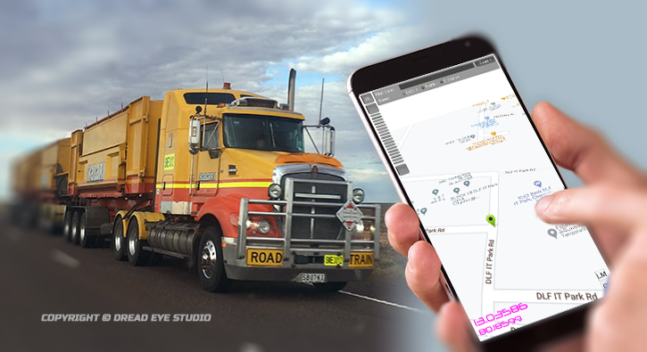

Fig 1.1 **Smart GPS System**

**1.2 Introduction and History of Electromagnetic Brake system**

**Introduction:**

Enhancement in Technology a lot of new technologies are arriving in the braking systems. The principle of braking is depending on the conversion of energy that is converted kinetic energy into thermal energy form of heat. In two wheeler Disc brake and drum brake are used in existing system, both braking are contact type braking as well as the frictional resistance braking. Dude to contact type braking losses are more like the wear and tear and so on. Also maintenance is required more like lubrication, replacement of auxiliary part due to wear and tear. There are few problems in the existing braking system. Realize the importance of the new braking system that reduced common problems mentioned earlier, experiment will be conducted to study of electromagnetic braking system. In this electromagnet electrical supply converted into magnetic field which act as magnetic force on the disc to be braked. In this braking system parameter influence to the braking force which is electrical current, air gap between the disc and the electromagnet etc. These are parameter will be design in this experiment. This type of braking system is more effective than the existing braking system. And all disadvantages of the existing braking system will be minimized in the electromagnetic braking system. Electromagnetic brakes are also called as Electro Mechanical Brakes. Stop motion using electromagnetic force to apply mechanical resistance form of frication. The original name was ‘Electro Mechanical Brakes’ but over the years the name changed to ‘Electromagnetic Brakes’, referring to their actuation method. Since becoming popular in the mid 20th century especially in trains and trams, the variety of application and brakes designs has increased dramatically but the basic operation remains the same. Electromagnetic brakes are the brakes working on the electric power and magnetic power. They work on the principle of electromagnetism. ‘Electromagnetic Brake Systems’ are the future of transportation safety using ‘Eddy Current Law’. Eddy current braking systems are a better alternative to the currently used friction based braking systems for instance disk and drum brakes.

**History:**

It is found that electromagnetic brakes can develop a negative power which represents nearly twice the maximum power output of a typical engine, and at least three times the braking power of an exhaust brake. These performances of electromagnetic brakes make them much more competitive candidate for alternative retardation equipments compared with other retarders. By using the electromagnetic brakes are supplementary retardation equipment, the frictions brakes can be used less frequently and therefore practically never reach high temperatures. The brake linings would last considerably longer before requiring maintenance and the potentially brake fade problem could be avoided. In research conducted by a truck manufacturer, it was proved that the electromagnetic brake assumed 80% of the duty which would otherwise have been demanded of the regular service brake. Furthermore the electromagnetic brake prevents the danger that can arise from the prolonged use of brake beyond their capability to dissipate heat. This is most likely to occur while a vehicle descending a long gradient at high speed. Ina study with a vehicle with 5 axles and weighting 40 tones powered by a powered by an engine of 310 bhp travelling down a gradient of 6% at a steady speed between 35 and 40 mhp, it can be calculated that the braking power necessary to maintain this speed to the order of 450 hp. The brakes, therefore, would have to absorb 300 hp, meaning that each brake in the 5 axels must absorb 30 hp, which a friction brake can normally absorb with self destruction. The magnetic brake is wall suited to such conditions since it will 9 independently absorb more than 300 hp. It therefore can exceed the requirements of continuous uninterrupted braking, leaving the friction brakes cool and ready for emergency braking in total safety. The installation of an electromagnetic brake is not very difficult if there is enough space between the gearbox and the rear axle. If did not need a subsidiary cooling system. It relay on the efficiency of engine components for its use, so do exhaust and hydrokinetic brakes. The exhaust brake is an on/off device and hydrokinetic brakes have very complex control system. The electromagnetic brake control system is an electric switching system which gives it superior controllability.

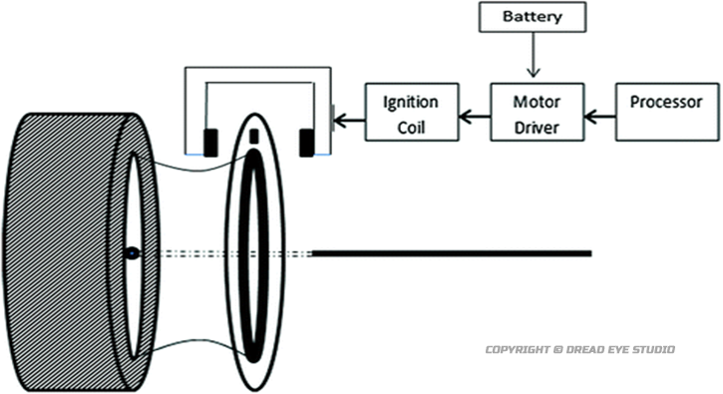

Fig 1.2 **Electromagnetic Brake system**

**Chapter 2: Literature Review**

**2.1 Literature Review of Advance Smart GPS System**

Nowadays GPS units are great tracking devices that help fleet managers stay in control of their business. The applications in today’s GPS units make it possible to take full control of any company. It is clear that the tracking devices offer many benefits to companies, since we can build automated expense reports anytime. GPS units do more than just allow companies to create reports. These devices also help to put an end to thieves. According to recent reports, crime is at a high, which means that car theft is increasing. If we have the right GPS unit, we can put an end to car thefts because we can lock and unlock our car anytime we want to. GPS is small tracking device that is installed in a car and it will supply feedback data from tracking software that loads from a satellite. In this paper GPS based vehicle navigation system is implemented. This is done by fetching the information of the vehicle like location, distance, etc. by using GPS and GSM. The information of the vehicle is obtained after every specified time interval defined by the user. Then this periodic information of location is transmitted to monitoring or tracking server. This transmitted information is displayed on the display unit by using the DES Global Map to display the vehicle location in the electronic DES Global Map. This system uses Global Positioning System (GPS) which is used to receive the coordinates of latitude and longitude form the satellite. We all know that tracking system is now a day a very important in modern world. This system can be used in the monitoring our car, also in tracking the theft of the vehicle and in many more other applications. This system uses microcontroller powered by DES MC300 Series (model 328), Global Positioning System (GPS) and Global System for Mobile Communication (GSM). Only one GPS device is used in this system and GSM enable a two way communication process. GSM modem is provide with a SIM card which uses the same and regular communication process as we are using in regular phone. This can also be done with WIFI Interface, If there is existing WIFI available in that source. From the above mentioned vehicle tracking techniques we can say that each technique is appropriate with its function but in some system we need continuous net access and this system can go down if net fails. In the first system the GPS tracks the vehicle location and send it to the controller (DES MC300 Series (model 328)). Its then decide to share via server to the user. On getting the data on user’s side the DES Global Map display the location of the Vehicle on the display unit, this system is useless without net because with ‘Error’ or ‘No Network’ user cont able to receive message sent by controller (DES MC300 Series (model 328)). In this case message is stored/Stack then when connected It send all the information back to that user. By considering all these factors the upcoming implementation should introduce many more facilities which will make the system user friendly and efficient.

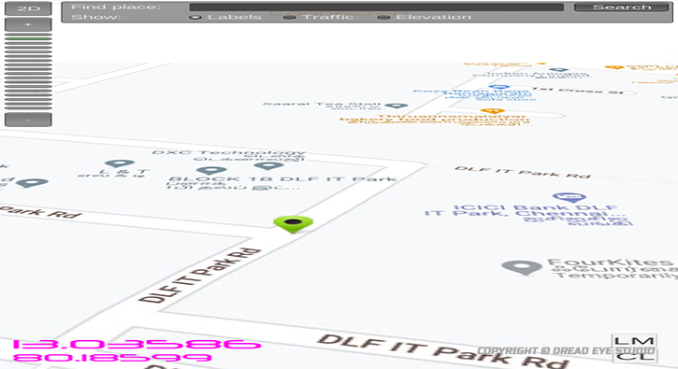

Fig 2.1 **Advance Smart GPS Map I**

**2.1.1 Active and Passive Tracking System**

Tracking System is classified as ‘passive’ and ‘active’. Passive devices store GPS location, speed, heading and also track information like trigger event for key press, door open or close. Once the vehicle returns to a predetermined point, the device is removed or using WIFI/BLUTOOTH etc to transfer data which then analysis with computer. Were as Active devices also collect same data as passive the only difference is it does in real time via cellular or WIFI over Internet. Passive trackers do not monitor movement in real time. Which mean it monitors it passive in local storage. Which can be accessed which in that source. After we have gathered all of the information we need from a passive tracker, we can place the tracker back on the same (or different) vehicle/source. The main reason people choose passive trackers is that these devices are less expensive than active trackers. GPS passive device are not attached to a monthly fee, which makes there trackers affordable. It all comes down to monitoring vehicle that need to be tracked at regular time interval or Passive way. Were as active GPS tracking devices can access at any time.

**2.1.2 Type of Tracking System**

There are three main types of GPS vehicle tracking that are widely used. There are:

* Assisted Global Positioning System (AGPS)
* Automatic Vehicle Location (AVL) system
* Radio Frequency Identification (RFID)

**Assisted Global Positioning System (AGPS):**

In AGPS system, a terrestrial RF network is used to improve the performance of GPS receivers as it provides information about the satellite constellation directly to the GPS receivers. AGPS uses both mobiles and cellular networks to locate the accurate positioning information. AGPS is used to overcome limitations of GPS. With unassisted GPS, locating the satellites, receiving the data and confirming the exact position may take several minutes. The tracking method of AGPS uses 4 satellites (3 satellites determine latitude, longitude and elevation and the fourth provides element of time) hence it never fails to detect the location of a vehicle. Location of the vehicle is provided with accuracy of between 3m and 8m, and the speed of 1Km by using this method. Information like vehicle location average speed, direction, and path traversed in a selected period and alerts Engaged/Unengaged, speed limit, vehicle breakdown and traffic jam are delivered by the tracking system to the base station. The system provides continues updates after every 10 seconds while the vehicle is in motion.

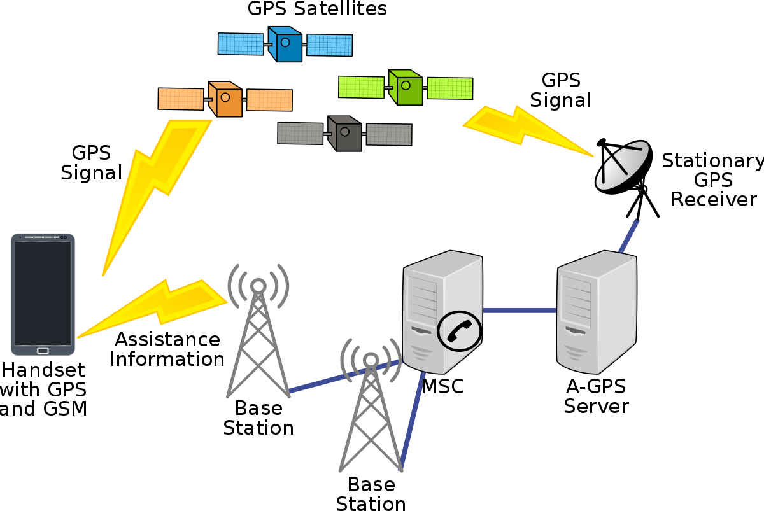

Fig 2.1.2 (i) **Assisted Global Positioning Systems (AGPS)**

**Automatic Vehicle Location (AVL) system:**

In AVL system is an advanced method to track and monitor any remote vehicle with the device that receives and sends signals through GPS satellites. AVL comprises of Global Positioning System (GPS) and Geographic Information System (GIS) in order to provide the real geographic location of the vehicle. AVL system consists of PC-based tracking software to dispatch, a radio system. Among the two types of AVL, GPS based and Signpost based. GPS based system is widely used. The tracking method uses GPS satellite to locate the vehicle equipped with GPS modem by sending satellite signals. The accuracy of the tracking method depends on the AVL system which provides the vehicle location with the accuracy of about 5m to 10m. The information transmitted by the tracking system to the base station is location, speed, direction, mileage, start and stop information and status of vehicle. The information of the vehicle is often transmitted to the central control system (base station) from the vehicle after every 60 seconds. If the base station receives the data, it displays it on a computerized map. GPS receiver on the vehicle receives the signals of its geographic location. Then the receiver sends that data plus speed, direction, etc. to the base station via a radio system. The system also has some limitation using the AVL system we cannot get accurate, complete and sufficient satellite data in dense urban areas or indoors and when transmission is blocked by natural obstructions or many buildings. It can also occur in RF-shadowed environments and under unfriendly Radio Frequency (RF) conditions. Sometimes, a position fix can be impossible.

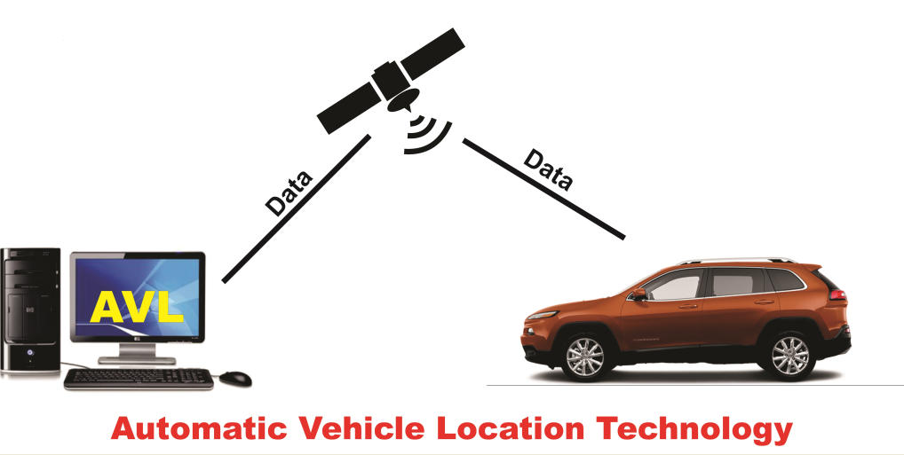

Fig 2.1.2 (ii) **Automatic Vehicle Location (AVL) system**

**Radio Frequency Identification (RFID):**

In RFID is an automatic identification method using devices called tags to store and remotely retrieves data. RFID uses radio waves to capture data from tags. The tracking method of RFID is comprised of three components: tag (passive, semi passive and active), reader (antenna or integrator) and software (middleware). RFID tag which contains microelectronic circuits sends the vehicle information to a remote RFID reader which is then read via the software. This system provides the location of the vehicle with the accuracy of 4m to 6m. Information such as location of the vehicle, mileage and speed are delivered by the tracking system to the centre. The information is updated every one minute. The information is sent to and received from RFID tags by a reader using radio waves.

**2.1.3 Functions of GPS System**

GPS is based on satellite ranging, distance from satellites. Satellites are precise reference points. We determine our distance from them. The GPS satellites transmit signals on two carrier frequencies.

**Determining GPS Position:**

Suppose the distance from Satellite A to our position is 11,000 miles, At this point we could be located anywhere on the specified sphere. Next, let’s take another measurement from a second satellite B. Now our position is narrowed down to the intersection of these two spheres. Talking another measurement from a 3rd satellite narrows our position down even further to the two points. Hence these spheres are intersected to form a point. This point is used to located accurate position of a user.

**2.1.4 Segments of GPS System**

There are three types of segments in GPS Tracking system, are as follows:

* Space Segment GPS System
* Control Segment GPS System
* User Segment GPS System

**Space Segment GPS System:**

GPS satellites fly in circular orbit, a semi major axis of 26,560 km, at a height of 20,200 km. The satellites have a speed of 3.9 km per second and a nominal period of 12h sidereal time. Orbital planes are centered on the Earth and each satellite makes two complete orbits each sidereal day which passes over the same location on Earth once each day. Orbits are designed so that at the very least, six satellites are always within line of sight from any location on the planet and the satellites continuously send radio signals towards earth. The nominal GPS satellite constellation consists of 24 space vehicles distributed in six orbital planes with an inclination of 55 degrees in relation to the equator. In addition, the constellation has 3 backup satellites.

Basic Functions of Satellites are follows:

* To receive and store data transmitted by the control station.
* To maintain accurate time with several onboard atomic clocks.
* To provide stable platform and orbit for the L-band transmitters.

**Control Segment GPS System:**

The GPS control Segment also referred to as Ground Segment or Operational Control System is responsible for the proper operation of the GPS system. The GPS control Segment is composed by a network of Estimate on board clock status and define the corresponding parameters to be broadcasted with refer to constellation master time. The orbit of each satellite in order to predict the precise orbital information along with the coarse orbital information. Determine the attitude and location of the satellites in order to determine the parameters to be sent to the satellites for correcting their orbits. Uploading the derived clock correction parameters and orbit correction commands to the satellites.

**User Segment GPS System:**

User Segment Consists of GPS receiver composed of as follows:

* An antenna internal or external tuned to the frequencies transmitted by the satellites.
* Receiver-processors
* A highly stable Clock (Crystal Oscillator)
* A Display System

Receiver clock is not as precise as the satellite clock. Receivers are classified by its no of channels and the major tasks for a receiver are as follows:

* Select the satellites in view.
* Acquire the corresponding signals and evaluate their health.
* Carry out the propagation time measurement.
* Provide accurate time.
* Calculate the location of the terminal and estimate the error.

**2.2 Literature Review of Electromagnetic Brake System**

**Principle of Electromagnetic Brake System**

If a piece of copper wire wound around the nail bar and then connected to the electrical supply, it would create that substance to act as an electro magnet. The magnetic field that is generated in the wire, from the current is known as “Right Hand Thumb Rule”. The Strength of the magnetic field can be changed by changing both wire size and the amount of wire turns. An Electromagnet is type of temporary magnet in which magnetic field is produced by a flow of electric current. The magnetic fields disappear when the current is lost. The wire produces loops of magnetic field lines around it, the current represents the movement of bar and resulting field line direction is the direction of turning. If a wire is wound into a coil, then the field lines add up in such a way as to produce a set of field lines surround the coil in a similar way to those that surrounds as a permanent bar magnet. If further a piece of soft iron is placed inside the coil, they themselves serve as many little bar magnets in the iron, creating a strong bar magnet as long as the current is switch on.

**Working of Electromagnetic Brake System**

A soft iron core that is magnetized by passing a current through a coil of wire wound on the core. Electromagnets are used to lift heavy masses of magnetic material and to attract movable magnetic parts like iron disc and ferrous material. When electric supply given to the electromagnet then it act as a temporary magnet this magnetic field exerted the force on rotation disc in the direction of perpendicular to the disc. In an engineering sense the word electromagnet does not refer to the electromagnetic brakes and clutches, and in attractive and lifting or holding magnets and magnetic chucks.

Electromagnets may be classified into two types:

* **Traction Magnets:**

In which the pull is to be exerted over a distance and work is done by reducing the air gap.

* **Lifting or holding magnets:**

In which the material is initially placed in contact with the magnet For Examples of the latter type are magnetic chucks and circular lifting magnets.

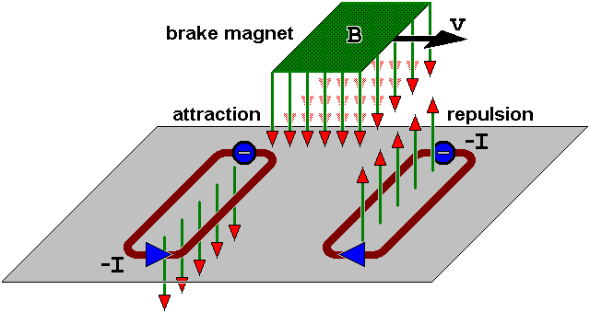

Fig 2.2 **Electromagnetic Brake System**

**Design and Practical Working:**

Theoretically, it is divided into three main units are Base unit, Driving unity and Braking Unit. Base unit consist of structural foundation of base unit, driving unit consist of an electrical motor, power control and bearing. Braking unit consists of an electromagnet. Electromagnetic brakes also called as Electro Mechanical Brakes. Stop motion using electromagnetic force to apply mechanical resistance by friction. The original name was “Electro Mechanical Brakes” referring to their actuation method. Since becoming popular in the mid 20th century especially in trains and trolleys, the variety of application and brake current brakes use electromagnetic force but electromagnetic brakes ultimately depend on friction and eddy current brakes use magnetic force directly.

**Material Selection:**

Material Selection process is depending on application of where the brake is used. Generally plate is mostly used in aluminum because it is very efficient to produce eddy current in plate. Preferred to use most effective copper plate but it is not cost efficient.

**2.2.1. Type of Brake System**

* **Electromagnetic Brake System:**

Rising style of brake system, electromagnetic brakes use an electric motor that is included in the automobile which help the vehicle come to stop. These types of brakes are in most hybrid vehicles and use an electric motor to charge the batteries and regenerative brakes. On occasion some buses will use it as a secondary retarder brake.

* **Frictional Brake System:**

Frictional brake system is found in many automobiles. It is typically found in two forms pads and shoes. As the name implies these brakes use friction to stop the automobile from moving. They typically include a rotating device with a stationary pad and a rotating weather surface. On most band brakes the shoe will constrict and rub against the outside of the rotating drum. Alternatively on a drum brake, a rotating drum with shoes will expand and rub against the inside of the drum.

* **Hydraulic Brake System:**

A hydraulic brake system is composed of a master cylinder that is fed by a reservoir of hydraulic braking fluid. This is connected by an assortment of metal pipes and rubber fittings which are attached to the cylinders of the wheels. The wheels contain two opposite pistons which are located on the band or drum brakes which pressure to push the pistons apart forcing the brake pads into the cylinders, thus causing the wheel to stop moving.

**2.2.2 Signification/Scopes of Electromagnetic Brake System**

* Electromagnetic brakes satisfy all the energy requirements of braking without the use of friction. They have better heat dissipation capability to avoid problems that friction brakes faces times.
* They can also be used as supplementary retardation equipment in addition to the regular friction brakes on heavy vehicles.
* These brake component cost is less so these brakes are cheap.
* They can be used as an alternative method for the future crisis of the crude oils.

**2.2.3 Limitations of Electromagnetic Brake System**

* The installation of an electromagnetic brake is very difficult if there is not enough space between the gearbox and rear axle.
* It cannot use grease or oil.
* Electromagnetic brakes are good at slowing things down, not completely stopping them.

**2.3 Objectives**

* **Primary Objective**

The main objective of our project is to design and fabricate an Electromagnetic Braking System model.

* **Secondary Objective**

Besides the main objective, following are our secondary objectives:

1. To understand project planning and execution
2. To understand the fabrication techniques in a mechanical workshop
3. To understand the usage of various mechanical machine tools and also measuring tools
4. To make day to day human life more easier by proper use of technology

**Chapter 3: Hardware Components**

**3.1 Introduction**

The core function of our project is to develop an electromagnetic brake and GPS tracking system that is cost effective so we have made use of the following hardware components that has effective operation and usage. We made usage of GPS module to capture location, speed and time of last received data in accordance. Then using GSM technology, the captured data already sent to the web server is stored and for this we have used SIM908 module.

**3.2 List of Components**

The following list of hardware components:

**3.2.1 DES MC300 Series (model 328)**

Microcontroller which is programmed made as a module is DES MC300 Series (model 328). It is microcontroller board based on the ATmega328PU. It has 32 KB (with 0.5 KB occupied by boot loader). It also has 2 KB of SDRAM and 1 KB of EEPROM (which can be read and written with the EEPROM library). It has 28 pin in total, 20 digital input/output pins of which 6 can be used as PWM output and 6 can be used as analog inputs, in circuit system programming (ICSP). Its clock at 16 MHz continuously no matter what the code is doing.

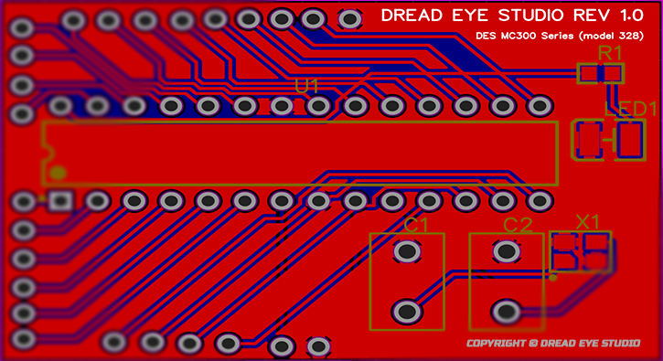

Fig 3.2.1 **DES MC300 Series (model 328)**

**3.2.2 SIM 908 Module**

SIM908 module is a complete Quad-Band GSM / GPRS module which combines GPS technology for satellite navigation. It has a SIM application toolkit where SIM card can be inserted. The compact design which integrated GPRS and GPS in a SMT package significantly saves both time and cost for one to develop GPS enabled applications. A modem GSM & GPRS with SIM908 module allows to create data connections on the GSM network through a standard USB interface. The cellular modems, particularly USB-stick ones, are now at very affordable prices. However, they are limited: they are explicitly designed for Internet connections, so one cannot use it as a normal modem and so implement, for example, a point to point data communications with them.

**3.2.3 GPS and GSM antenna**

**GPS antenna:**

This GPS antenna draws about 10mA and will give you an additional 28 dB of gain. It got a 5 meter long cable so it will easily reach wherever it is needed to. The antenna is magnetic so it will stick to the top of a car or truck or any other steel structure. GPS signals are extremely weak and present unique demands on the antenna so the choice of antenna plays an important role in GPS performance. A GPS unit needs to have a clear, unobstructed sky view, to best receive the microwave signals that allow it to communicate with satellites. GPS Down/Up converter used for very long cable runs. This GPS antenna that receives the GPS signal, converts it to a lower frequency which is then sent down the cable. Next to the GPS receiver is an up converter that converts the signal back to the original frequency and delivers it to the GPS receiver.

**GSM antenna:**

GSM communications are dependent on antennas. The antenna is what allows communications signals to be sent and received. The antenna that we have used in our project provides operation at both GSM Quad Band Frequencies with +2dBi gain. This antenna operates in Quad Band 890/960, 1710/1880 MHz Frequencies and it’s a unidirectional.

**3.2.4 Relay Switch**

The electro-mechanical relay is an output device (actuator) which comes in a whole host of shapes, sizes and designs, and has many uses and applications in electronic circuits. But while electrical relays can be used to allow low power electronic or computer type circuits to switch relatively high currents or voltages both ‘ON’ or ‘OFF’, some form of **relay switch circuit** is required to control it. Relay switch is of two types NPN relay switch circuit and PNP relay switch circuit. In this case relay is used to act as a transmitter which handles high current. Most relays actuated by electromagnetic behavior. Relays can be controlled with lower voltage and current to switch ‘ON’ or ‘OFF’ high power source.

**3.2.5 Battery**

A battery is a device consisting of one or more [electrochemical cells](https://en.wikipedia.org/wiki/Electrochemical_cell) with external connections for powering [electrical](https://en.wikipedia.org/wiki/Electricity) devices such as [flashlights](https://en.wikipedia.org/wiki/Flashlight), [mobile phones](https://en.wikipedia.org/wiki/Mobile_phone), and [electric cars](https://en.wikipedia.org/wiki/Electric_car). When a battery is supplying [electric power](https://en.wikipedia.org/wiki/Electric_power), its positive terminal is the [cathode](https://en.wikipedia.org/wiki/Cathode) and its negative terminal is the [anode](https://en.wikipedia.org/wiki/Anode). Battery is used to supply power to electric component of this system without which it can’t run. It can be in series or parallel connection for increasing current or voltage respectively. While connecting positivity to negative the electron with negative charger flows from opposite direction from negative to positivity terminal. Internal resistant of a battery is import while connecting it to series or parallel to get increased power.

**3.2.6 Wheel**

The electromagnet is the key component of this project. I used the only one available to me, which was a Parker Skinner Valve solenoid 24v DC. Just about any reasonably sized electromagnet should suffice for collecting data, but if you are interested in implementing this system on a bicycle you will, as we shall see, need a much larger electromagnet. In order for the electromagnet to function properly, there needs to be a ferromagnetic disc upon which the electromagnet can induce a magnetic field. The larger disc is better. Once again, we used what was available. Specifically, I used six 20.32 cm (diameter), 1 mm thick steel discs. Since the wheel already had a disc brake rotor, we were able to drill holes in the steel discs so that they could easily attach to the hub. After the ferromagnetic disc is set, there needs to be a way to position the electromagnet. In the case that the electromagnet is a valve solenoid, the central bolt can be secured through a hole in the frame. I used nylon spacers, washers, and a nut to secure the solenoid. The bolt was wrapped in electrical tape so that it would not slide out of the solenoid. Furthermore, a hole was drilled through its center so that another, smaller bolt could secure the solenoid onto the larger bolt. Once the solenoid is in place, the wires can be connected to the terminal strip. Make sure the bolt is as close to the disc as possible. When I did it, the bolt was about 1mm from the disc. Any closer and the magnetic force from the bolt would cause surface contact. If it gets too close, you may want to add some cardboard or paper spacers in between the hub and the brace.

**3.2.7 Frame**

Electro Mechanical disk brakes operate via electrical actuation but transmit torque mechanically. When electricity is applied to the coil of an electromagnet, the magnetic flux attracts the armature to the face of the brake. As it does so, it squeezes the inner and outer friction disks together. Electromagnetic braking means applying brakes using electronic and magnetic power. Also traditional braking systems are prone to slipping while this one is guaranteed to apply brakes to the vehicle. So without friction or need of lubrication this technology is a preferred replacement for traditional braking. Disk electromagnetic brakes are used on vehicles such as trains, and power tools such as circular saws, to stop the blade quickly when the power is turned off. There are two kinds of service brakes or the brakes that stop your vehicle while driving disc and drum brakes. Additionally, almost all vehicles come with emergency brakes and anti-lock brakes. Thus this model is created in high resolution With CATIA - (16 K res).

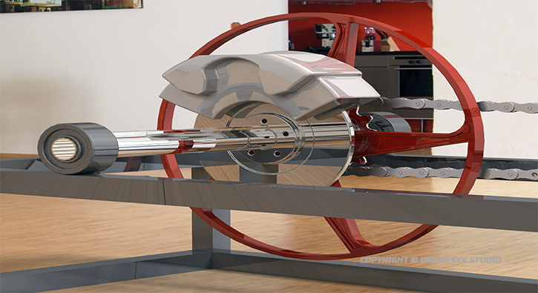

Fig 3.2.7 (i) **Frame front view**

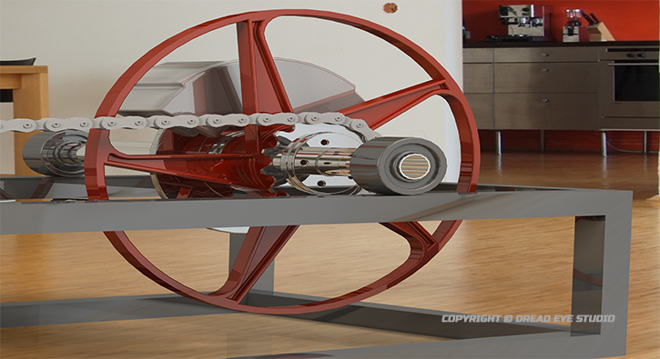

Fig 3.2.7 (ii) **Frame rear view**

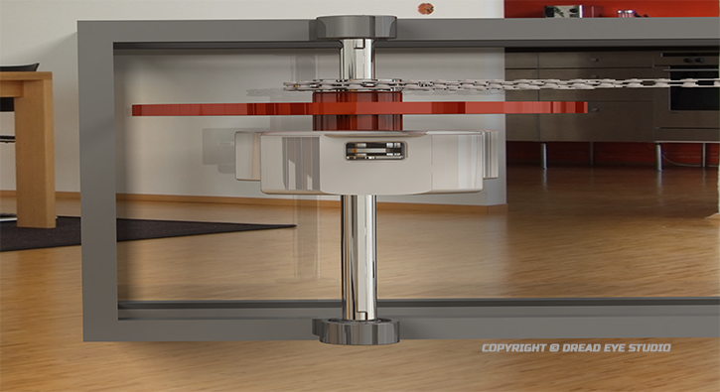

Fig 3.2.7 (iii) **Frame top view**

**3.2.8 Electric Motor**

An electric motor is an electrical machine that converts electrical energy into mechanical energy. Most electric motors operate through the interaction between the motor's magnetic field and electric current in a wire winding to generate force in the form of torque applied on the motor's shaft. Electromagnetic brakes slow or stop motion using electromagnetic force to apply mechanical resistance. They were originally called "Electro Mechanical Brakes”, but over the years the name changed to "Electromagnetic Brakes", referring to their actuation method. Motor brakes generally use friction between mating surfaces to stop or hold a load. They generate friction and braking torque in one of two ways spring set or permanent magnet. Both methods use an electrical coil that, when voltage is applied, moves the friction faces apart to disengage the brake. When electricity is applied to the coil of an electromagnet, the magnetic flux attracts the armature to the face of the brake. As it does so, it squeezes the inner and outer friction disks together. The hub is normally mounted on the shaft that is rotating. There is no contact between braking surfaces and minimal drag. Dynamic braking is another method for breaking a motor. It is achieved by reconnecting a running motor to act as a generator immediately after it is turned off, rapidly stopping the motor. The generator action converts the mechanical energy of rotation to electrical energy that can be dissipated as heat in a resistor. Brake torque is the force applied at the brake wheel to stop the motion of the moving equipment. Assuming the operating conditions for the equipment are constant, a brake having a retarding torque equal to the full load torque of the motor to which it is applied is usually satisfactory.

**Chapter 4: Software Components**

**4.1 Introduction**

To make all this work configuration and setting up and building micro controller with communicating with servers involved in proper functioning of ‘Smart GPS and Electromagnetic System’. GPS receiver receives the data information mainly latitude and longitude of all added vehicle via network provider [ISP]. . For this project list of services required for setting up this service.

**4.2 List of Services**

The list of service that involve ‘Smart GPS and Electromagnetic System’ function using DES VPS Servers, DES Global Map, Database (mysql, perl), Mobile app Build (C#, Java (JDK), Android SDK, Android NDK,), Visual Studio for coding editor, Arduino IDE for uploading programmable instruction to DES MC300 Series (model 328) micro controller.

**4.2.1 DES VPS Server**

Dread Eye Studio has Data center located across the world to provide well optimized experience. DES has Game Server, Web Servers [Dedicated, VPS, Shared Hosting Service], Mail Servers, Global Map Servers, Storage Servers, DNS Server, etc. Does for this project will be using VPS from DES servers. In this server will be updating the GPS location data from the transceiver to receiver in this case mobile device through DES app. Also storing multiple variables for tracking path of the transceiver. Thus helping to gather data from DES cloud Global Map server to pull tilled map and get the location of transceiver.

**4.2.2 DES Global Map**

Dread Eye Studio has developed a world map similar to Google map via tilling for mapping service. It offers online and offline version of the map, normal map, satellite map, traffic map and more. This map is used to locate vehicle in its location. It is converted into dll API files to work with android apps and windows application. Using this can add key points or navigation to work. The tilled map takes parameter of latitude and longitude and time to calculate location of the receiving object as well as its speed with uses of atomic clock in GPS satellite which is accurate.



Fig 4.2.2 **DES Global Map II**

**4.2.3 Database [DB]**

It’s a storage base in which data is storage in order for each user. A database is designed, built and populated with data for specific purpose. A database management system (DBMS) is a software system to create and manage the database. It helps the users or programmers to update, retrieve, create and manage the data in a proper way. DBMS interacts with the user, other applications, and the database itself to capture and analyze data. The DBMS manages three important things: the data, the database engine that allows data to be accessed, locked and modified and the database schema, which defines the database’s logical structure. This three foundation elements provide concurrency, data integrity, security and uniform administration procedures. Using SQL can Create Drop, Alter, Change, etc.

**4.2.4 Mobile App Build**

Mobile app is developed for android which is cross platform supported such as Windows, Linux, and Mac. This Advance Smart GPS app is build with Android SDK, JDK, and NDK for dependency and compatibility. API such as DES Global Map in form of dll files are also added with this pack to access map raw tilled data over online and offline. This app which is build from scratch to working level.

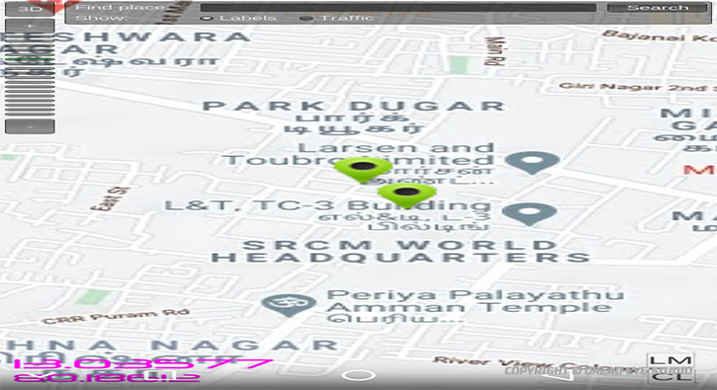

Fig 4.2.4 **Mobile App Build GPS Map**

**4.2.5 Visual Studio**

Microsoft Visual Studio is a code editor for compiling and writing code. Microsoft Visual Studio is an integrated development environment (IDE) from Microsoft. It is used to develop computer programs, as well as websites, web apps, web services and mobile apps. Visual Studio includes a code editor supporting IntelliSense (the code completion component) as well as code refactoring.

**4.2.6 Arduino IDE**

Arduino IDE is also a code editor and with programmable to micro controllers and execute them. The Arduino Integrated Development Environment (IDE) is a cross-platform application (for Windows, macOS, Linux) that is written in functions from C and C++. It is used to write and upload programs to Arduino compatible boards, but also, with the help of third-party cores, other vendor development boards. It also allows to serial into micro controller for advance controller over it.

**Chapter 5: System Design and Analysis**

**5.1 System Design and Analysis of Advance Smart GPS System:**

**5.1.1 System Design:**

Vehicle tracking device is made up with DES MC300 Series (model 328), SIM 908 module including GPS and GSM antenna. The core part of tracking system is microcontroller DES MC300 Series (model 328) with GPS and GSM System. The geo location of a vehicle can be captured through GPS receiver and that data will be transmitted to the web server [DES VPS Server] by using GSM technology. That data will be stored in a database. For monitoring the location of the vehicle on the map, we had developed a mobile application. We made up this application with PHP, HTML and JavaScript, DLLs programming, C#, C++. For storing the location data, a Database server had been used. The SIM 908 module is initialized to start gathering geo location data from the satellite device initialization is done using AT commands and includes GPS and GSM module; to turn on the GPS, first it is powered on and put in reset mode. Then the module become ready for receiving coordinates from satellite. The GPRS is next turned on; the process includes GPRS power on, setting APN of service provider, initiating HTTP protocol, and setting protocol method (Get method). Device initialization process may take up to 1 minute to worm up and calculate the accurate position. In case of network un-availability, the acquisitioned GPS coordinates and other data such as time and speed are stored temporarily until the network returns back to service then the stored coordinates are sent with their time stamp and speed. SIM 908 requires 2A peak current. So, external power supply like 12V, 2A battery is used to provide the power. GPS antenna and GSM antenna are connected to the port of SIM 908 module. The module and DES MC300 Series (model 328) have a common ground. We had uploaded the program into the DES MC300 Series (model 328) microcontroller which program is written in C programming language. Uploading program into DES MC300 Series (model 328) is done by using IDE software.

**5.1.2 Working of the System:**

In vehicle tracking system, GPS receiver receives the location data like latitude and longitude of a vehicle and send them by using a HTTP request to web server. Then browser is used to load the PHP webpage which contain DES Global Map to show the location of the vehicle in real time. At the initial stage, SIM 908 module has been powered up by using 12V battery rather than using 5V from DES MC300 Series (model 328). While the SIM 908 module draws 2A peak current, a huge voltage drop across it and then SIM 908 module has automatically been shut down. Therefore we need to use the external source to provide power to the system. Moreover, as our tracking system is used for the vehicle, so we can use the vehicle battery to provide power to the system. The applications in today’s GPS units make it possible to take full control of any company. It is clear that the tracking devices offer many benefits to companies, since we can build automated expense reports anytime. GPS units do more than just allow companies to create reports. These devices also help to put an end to thieves. According to recent reports, crime is at a high, which means that car theft is increasing. If we have the right GPS unit, we can put an end to car thefts because we can lock and unlock our car anytime we want to. GPS is small tracking device that is installed in a car and it will supply feedback data from tracking software that loads from a satellite. In this paper GPS based vehicle navigation system is implemented. This is done by fetching the information of the vehicle like location, distance, etc. by using GPS and GSM. The information of the vehicle is obtained after every specified time interval defined by the user. Then this periodic information of location is transmitted to monitoring or tracking server. This transmitted information is displayed on the display unit by using the DES Global Map to display the vehicle location in the electronic DES Global Map. This system uses Global Positioning System (GPS) which is used to receive the coordinates of latitude and longitude form the satellite. We all know that tracking system is now a day a very important in modern world. This system can be used in the monitoring our car, also in tracking the theft of the vehicle and in many more other applications. This system uses microcontroller powered by DES MC300 Series (model 328), Global Positioning System (GPS) and Global System for Mobile Communication (GSM). Only one GPS device is used in this system and GSM enable a two way communication process. GSM modem is provide with a SIM card which uses the same and regular communication process as we are using in regular phone. This can also be done with WIFI Interface, If there is existing WIFI available in that source. From the above mentioned vehicle tracking techniques we can say that each technique is appropriate with its function but in some system we need continuous net access and this system can go down if net fails. In the first system the GPS tracks the vehicle location and send it to the controller (DES MC300 Series (model 328)). Its then decide to share via server to the user. On getting the data on user’s side the DES Global Map display the location of the Vehicle on the display unit, this system is useless without net because with ‘Error’ or ‘No Network’ user cont able to receive message sent by controller (DES MC300 Series (model 328)). In this case message is stored/Stack then when connected It send all the information back to that user. By considering all these factors the upcoming implementation should introduce many more facilities which will make the system user friendly and efficient. SIM 908 module is run by using AT command in the program of DES MC300 Series (model 328). Initially, the network registration is done by using AT+CREG and set Access Point Name (APN), user name and password. After that turn on the GPS power supply using the command CGPSPWR and current GPS location information can be gotten using AT+CGPSINF command. After getting the data of vehicle’s location we have used two methods to send the data to the user end. If the user or owner of the vehicle sends a SMS to the mobile number which SIM card is used into the SIM 908 module, it will continuously send the SMS to the user’s mobile of the current location. Another way, by using HTTP request to web server the data has been sent via web stream with DES servers. For sending SMS, AT+CMGS command is used in the program and AT+CMGR command is used to read the SMS which has been sent from the user. For setting the configuration of GPRS, AT+SAPBR command has been used. To access the internet HTTP service, AT+HTTPINIT is used to initialize HTTP service, HTTPPARA command is used to set the parameters value.

**5.1.3 Calculations for Advance Smart GPS System:**

The GPS calculation in the receiver uses four equations in the four unknowns x, y, z, tc, where x, y, z are the receiver’s coordinates, and c is the time correction for the GPS receiver’s clock. The four equations are as follows:

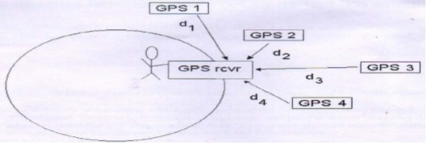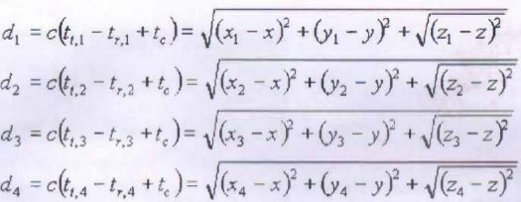

Where,

c = speed of light (3 x 108 m/s)

tt,1 , tt,2 , tt,3 = times that GPS satellites 1, 2, 3, and 4, respectively, transmit their signals. These provided to the receiver as part of the information that is transmitted.

Using the Haversine formula:

a = sin²(Δφ/2) + cos φ1 * cos φ2 * sin²(Δλ/2);

c = 2 * atan2( √a, √(1−a) );

d = R * c;

Calculating distance using Haversine Formula with GPS Coordinates.

**5.2 System Design and Analysis of Electromagnetic Brake System:**

**5.2.1 System Design:**

An Electromagnetic Braking system uses Magnetic force to engage the brake, but the power required for braking is transmitted manually. Electromagnetic braking system is a modern technology braking system used in light motor & heavy motor vehicles. This system is a combination of electro-mechanical concepts. If a piece of copper wire wound around the nail bar and then connected to the electrical supply, it would create that substance to act as an electro magnet. The magnetic field that is generated in the wire, from the current is known as “Right Hand Thumb Rule”. The Strength of the magnetic field can be changed by changing both wire size and the amount of wire turns. An Electromagnet is type of temporary magnet in which magnetic field is produced by a flow of electric current. The magnetic fields disappear when the current is lost. The wire produces loops of magnetic field lines around it, the current represents the movement of bar and resulting field line direction is the direction of turning. If a wire is wound into a coil, then the field lines add up in such a way as to produce a set of field lines surround the coil in a similar way to those that surrounds as a permanent bar magnet. If further a piece of soft iron is placed inside the coil, they themselves serve as many little bar magnets in the iron, creating a strong bar magnet as long as the current is switch on.

**5.2.2 Working of the System:**

If a piece of copper wire was wound, around the nail and then connected to a battery, it would create an electro magnet. The magnetic field that is generated in the wire from the current is known as the “right hand thumb rule”. Whenever the current carrying conductor cuts the magnetic field, the “e.m.f” (Electromagnetic force) is induced. The electromagnetic braking system is based on the creation of eddy currents within a metal disc rotating between two electromagnets which set up a force opposing the rotation of the disc. If the electromagnet is not energized, the rotation of the disc is free and accelerates uniformly under the action of the weight to which its shaft is connected. When the electromagnet is energized, the rotation of the disc is retarded and the energy absorbed appears as heating of the disc. The model works with the principle of electromagnetic field where the wheel is made to run at a speed with the help of a motor or manually, when the wheel is at a certain speed or rpm the power provided to it is released and the wheel is on the free movement it is then the brakes are applied where the two electromagnets are mounted close the disc and an air gap is maintained between the disc and the electromagnet of 0.5mm. The electromagnets gets engaged only when there is a supply of DC power to it, but before that the model is been automated with a regulator, relay and a RF channel controller. Where the regulator generates a fixed output voltage from the supply and to regulate one or more voltages, whereas the relays are the switches that opens and closes the circuit by electrically or electromechanically and they control the circuit by opening and closing contacts in another circuit. The RF channel is the device used to switching on and off of the application by means of a remote controller where by transmitting the signal to the relay and the operation is performed accordingly. The automated set up is connected to the power supply where then the circuit is connected to the electromagnets so that the automation can be done easily. When the wheel is rotating at a certain revolutions for a period of time the wheel is made to retard or stop with the help of the electromagnets by the help of the electromagnetic field, where the setup is operated by controlling the RF channel remote control where the rotating wheel can be stopped by controlling the RF controller where the controller transmits the signal to the relay where the relay is then activates the circuit and then it directly activates the electromagnets where the electromagnets tends to stop the wheel by applying the force to the disk and hence the wheel is made to stop in fraction of seconds and the controller is disengaged where then the automated setup disengages the electromagnets and then the wheel and the disk connected to it is left free. Thus the amount of retardation in the wheel is made to slow down or stop in an efficient way. Electromagnetic brake chips away at the rule of electromagnetism. They are absolutely contact less. Because of this they have longer life expectancy and solid. Less upkeep is required in these brakes. It can be utilized as supplementary brakes and can likewise use to quit turning shafts of high review machines in enterprises. This brake utilizes both swirl current and fascination power of magnet to stop vehicle. Swirl current is utilized to hinder the vehicle while attractive power is accustomed to convey vehicle to rest. This braking depends on fascination property of magnets. So when the rotor moves between the calipers, the electromagnets in the caliper pull in the lasting magnet in rotor. Since, electromagnets in caliper are settled; they endeavor to turn the rotor inverse way i.e. decelerating it. The deceleration is finished by expanding attractive field by expanding current supply to the electromagnets. The present supply for electromagnets in caliper is finished by wiring through caliper to battery. The center segment of rotor has structure like round thick plate and solid electromagnet is put before it. The leeway between rotor center part and electromagnet is less. While driving an auto, solid electromagnet situated before rotor center bit is turned on, along these lines shaping an attractive motion. This attractive motion is oppositely brought into rotor. A vortex current is in this manner incited in the tweaked rotor because of the Faraday's law. A Lorentz compel is created by the relative activity between the swirl current and the attractive transition, in this manner framing a braking torque. Vortex current does not decelerate vehicle at low speed. That`s why anticipated brake is blend of both attractive power and swirl current.

**5.2.3 Calculations for Electromagnetic Brake System:**

* Force at wheel lock or maximum braking force can be calculated as following:

**FL = Mdal × g × ur**

Where,

FL = possible braking force on axle

Mdal = dynamic axle load g = acceleration due to gravity

ur = coefficient of friction between road and tire

* Braking torque require to stop wheel as following:

**T = BF × R/r**

Where,

BF = Braking force

T = brake torque

R = radius of tire

r = speed ratio between the wheel and brake

* Braking force obtained by eddy current as following:

**Fe = pie × D2 × d × B02 × c × v/4ρ**

**c = ½ [1 – (1/4) * 1/(1 + r/A)2 (A – r/D)2]**

Where,

Fe = braking force (N)

D = diameter of soft iron pole (m)

d = disk thickness

B0 = air gap induction at 0 speed (T)

A = disk radius (m)

c = proportionality factor

ν= tangential speed of the rotating disk

ρ = specific resistance of disc material.

* Area of the Electromagnet = 10 m
* Current & Voltage supplied (I/V) = 7amp/230volts.
* Length of electromagnet (L) =90 mm.

Let the plate & wheel assembly maximum weight is to be considering approx. 2kg. Which is 20N so that will be:

**F = [B2A/2µo]**

Where,

F = Is the force in Newton.

B = Is the magnetic field in teslas.

A = is the area of the pole faces in square meters.

In the case of free space (air):

**µo = [4π x 10-7 H.m-1]**

20 = B2(10) / 2 x 4π x 10-7

B2(10) = 20 x (2 x 4π x 10-7)

B2 = [20 x (2 x 4π x 10-7)] / 10

B2 = 0.000000502654

B = 2.24 x 10-3

**B = 0.00224 wb/m2**

Total magnetic flux in core :

**Ø = B ×A**

Ø = 0.00224×20

**Ø = 0.0448 wb.**

The magnetizing force :

**H = B/µo**

H = 0.00224/4π×10^-7

**H = 1782.53 AT/m**

For air gap of 0.5 mm magnetic force is given by between magnet and plate.

G1 = 0.5

N = number of turns in the electromagnetic = 1200

**F = [(NxI)2µoa / (2xg)] = [(NxI)2µoa / (2G1)]**

F= (12x1)2 4πx10-7 x0.00224 / (2x0.5)2

**F = 32.208 N**

Single phase AC motor:

* Power = 12v/5A = 60 watt
* Speed = 0-9500 (var)

Motor Torque,

**P = [2πNT/60]**

T = [(60 x 60) / (2π x 9500)]

**T = 0.0603 N-m**

Performance Testing:

* Speed taken (Constant) = 3000 rpm
* R = radius of wheel

**V = rὡ**

V = 0.9x (2πn/60)

V = 0.9x (2π3000/60)

**V = 282.74 m/s**

According to Newton’s law of motion:

ui = 282.74 m/s

vf = 0

**V = u+at**

a = (v-u) / t

a = (0-282.74) / 3

**a = -94.25 m/s2**

Hence the deceleration of the electromagnetic braking system takes place according to the braking time.

**Chapter 6: Summary and Conclusions**

**6.1 Summary and Conclusion:**

The data collected can be viewed on electronic maps via internet and software. The device includes modern hardware and software components that help to track and locate automobiles both online and offline. GPS is a fantastic tool of the 21st century offering many functions. However, received information is not always reliable, and it would have been interesting to see in which cases it is not. To the computers of the world our locations may be defined not by a street address, a city, and a state, but by longitude and latitude. The proposed vehicle tracking and monitoring system can be used to alert Fleet Managers in case of unnecessary acceleration, harsh braking, routing, and speedy driving. This is extremely useful in case of school buses, trucks and containers carrying sensitive items like fuel, gas and other inflammable goods. Also this work is important to check the conditions of the main spare parts of each vehicle such as tires, oil filter, air filter, and oil engine. Electromagnetic Braking is superior to conventional frictional braking as there is no friction and heat in electromagnetic braking. So the conventional disc and drum brakes can be replaced with electromagnetic brakes. Electromagnetic brakes have numerous preferences over frictional slowing mechanism. These System can be controlled from Mobile app, Smart GPS System is a system in which can integrate all vehicles into one app to track data and analyze from different place regardless of vehicles location. This Smart GPS System Project is copyrighted (©) by ‘Dread Eye Studio’. This project definitively answers the question regarding elimination of theft & future proof. Further studies are needed to establish crucial for safety & preventative measures.

**REFERENCES**

**[1]** Scott Pace, Gerald P. Frost, Irving Lachow, Dave Frelinger, Donna Fossum, Don Wassem, Monica M. Pinto. The Global Positioning System, Assessing National Policies, Appendix B: G PS History, Chronology, and Budgets, monograph/report products, Rand Corporation.

**[2]** Analysis of an eddy-current brake considering finite radius and induced magnetic flux- Journal of Applied Physics, Kapjin Lee, Kyihwan Pa.

**[3]** Journal- Eddy Current in Magnetic Brakes- Henry A. Sudano and Jae Sung Bae.

**[4]** K D Hahn, E M Johnson, A Broken & S. Baldwin (1998) "Eddy Current damaging of a magnet moving through a pipe", American Journal of physics 66. '1066-66.

**[5]** M.A Heald (1988) "Magnetic braking: Improved theory", American Journal of physics 56: 521-2.

**[6]** Y. Levin, S L. Da Silveria & F. B Rizzato (2006) "Electromagnetic braking: S Simple quantitative model", American journal of physics 74: 815-17.

**[7]** Sears Francis Weston: Zemansky, Mark W. (1955), University Physics (2nd Ed), Reading MA. Addison-Wesley.

**[8]** SisKind, Charles S (1963). Electrical control system in industry, New York: Mcgraw-Hill, Inc, ISBN 0-87-057746-3.

**[9]** H. D. Wiederick. N. Gauthier. D. A. Campbell & P. Rochan (1987) "Magnetic Braking: Simple theory and experiment", American journal of physics 55:500-3.

**[10]** US patent 7237748, Steven Sullivan, "Landing gear method and apparatus for braking and maneuvering", is issued 3 July 2007, assigned to Delos.

**[11]** Fleming Frank: Shapiro, Jessica "BASIC OF ELECTROMAGNETIC BRAKES".